**Air University**



**Mid Semester Lab Examination: Fall 2021**

Subject: - **Computer Networks**

Course Code: -

Class: - **BS-CYS**

Semester: - **3rd**

Section(s): - A

Total Marks: 30

Date: 3/11/2021

Time: 12 PM to 2 PM

Max Time Allowed: 2 Hours

FM(s) Name: **Adnan Shah**

**Student’s Name:**  **Sameer Ahmed**           **Reg-ID: 200973**  
https://lh3.googleusercontent.com/vUdyzec6vf4adeuCbT-kSLCrgHtcZ73oo8OzwrQXQ0WTJbslXkgcWaaFOdFigE-Yx9OUR5C0-ftwh1okePCdxm9hg9i-Q0GHSOSJTRrQsFxuiiI0uBDEE2leXq5idr8UNlsmBn04-s28NzZiQQ

**Instructions:**

* Each Question contains equal marks
* Task based practical examination

* Compile complete report in PDF format which includes all task screenshot.
* Plagiarism of any kind will result in Zero (0) marks.

https://lh3.googleusercontent.com/vUdyzec6vf4adeuCbT-kSLCrgHtcZ73oo8OzwrQXQ0WTJbslXkgcWaaFOdFigE-Yx9OUR5C0-ftwh1okePCdxm9hg9i-Q0GHSOSJTRrQsFxuiiI0uBDEE2leXq5idr8UNlsmBn04-s28NzZiQQ

**CLO 2**

**Question 01:**

Calculate IP Addresses produced after applying the “formula (mathematical calculation for each IP)”. Identify Class, Private/Public, Valid/Invalid and Reserved/Not Reserved for each of calculated IP Address.

1. 1*Student-ID % 200. 1*Student-ID % 150. 1*Student-ID % 100. 1*Student-ID % 50.
2. 2*Student-ID % 200. 2*Student-ID % 150. 2*Student-ID % 100. 2*Student-ID % 50.
3. 3*Student-ID % 200. 3*Student-ID % 150. 3*Student-ID % 100. 3*Student-ID % 50.
4. 4*Student-ID % 200. 4*Student-ID % 150. 4*Student-ID % 100. 4*Student-ID % 50.
5. 5*Student-ID % 200. 5*Student-ID % 150. 5*Student-ID % 100. 5*Student-ID % 50.

**Ans:**

**ID:** 200973

1. 1*200973 % 200. 1*200973 % 150. 1*200973 % 100. 1*200973 % 50.

* Calculated IP: **173.123.73.23**
* Class: **B**
* Private/public: **Public**
* Valid/Invalid: **Valid**
* Reserved/Not reserved: **Not Reserved**

1. 2*200973 % 200. 2*200973 % 150. 2*200973 % 100. 2*200973 % 50.

* Calculated IP: **146.96.46.46**
* Class: **B**
* Private/public: **Public**
* Valid/Invalid: **Valid**
* Reserved/Not reserved: **Not Reserved**

1. 3*200973 % 200. 3*200973 % 150. 3*200973 % 100. 3*200973 % 50.

* Calculated IP: **119.69.19.19**
* Class: **A**
* Private/public: **Public**
* Valid/Invalid: **Valid**
* Reserved/Not reserved: **Not Reserved**

1. 4*200973 % 200. 4*200973 % 150. 4*200973 % 100. 4*200973 % 50.

* Calculated IP: **92.42.92.42**
* Class: **A**
* Private/public: **Public**
* Valid/Invalid: **Valid**
* Reserved/Not reserved: **Not** **Reserved**

1. 5*200973 % 200. 5*200973 % 150. 5*200973 % 100. 5*200973 % 50.

* Calculated IP: **65.15.65.15**
* Class: **A**
* Private/public: **Public**
* Valid/Invalid: **Valid**
* Reserved/Not reserved: **Not** **Reserved**

**CLO 3**

**Question 02:**

Using the **NET SHARE** command perform the following:

**Ans:**

Reg: **200973**

1. Create a directory:
   1. Name format: networkexam{Reg}

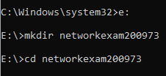

1. Create a NEW SHARE for this directory.
   1. Name format: networkexamshare{Reg}
2. Grant all users (everyone) with **CHANGE** permission
3. Set the allowed no. of users equal to the combination of first & last digits of your Reg.Number

**2**0097**3-🡪23**



1. Display the information for the **SHARE** you have created

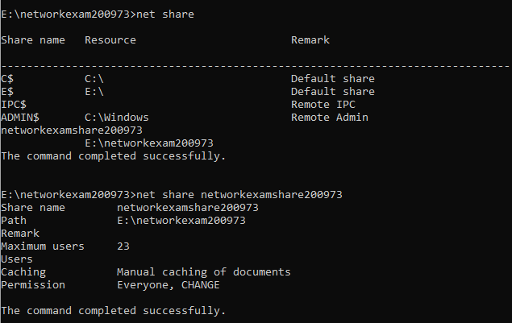

**CLO 3**

**Question 03:**

TASK-1: ROUTE

**Ans:**

1. Display the route table

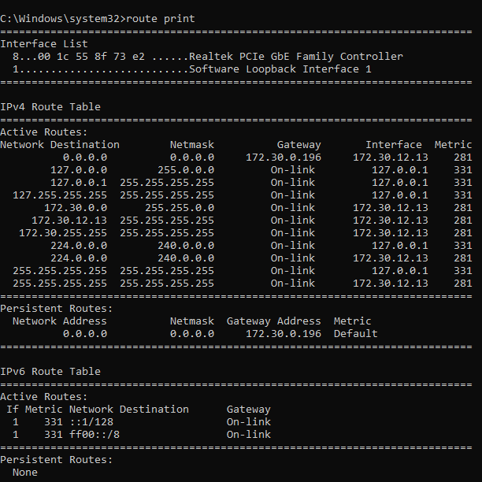

1. Find the “Gateway” for your network.

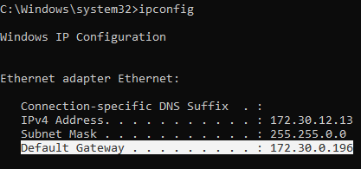

1. Using ROUTE command add a route with the following values:
   1. Destination IP = 148.66.137.120
   2. Gateway = {Your Network Gateway}
   3. METRIC = 100



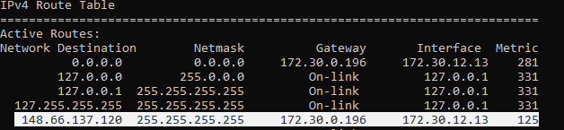

  TASK-2: NETSH

   Using NETSH command Display and Save the following:

1. Information about Network IP configuration

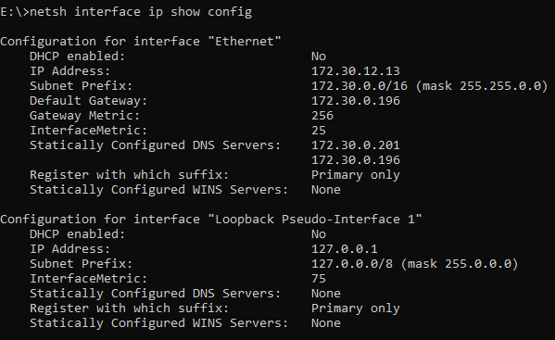

1. Information about all TCP Connections

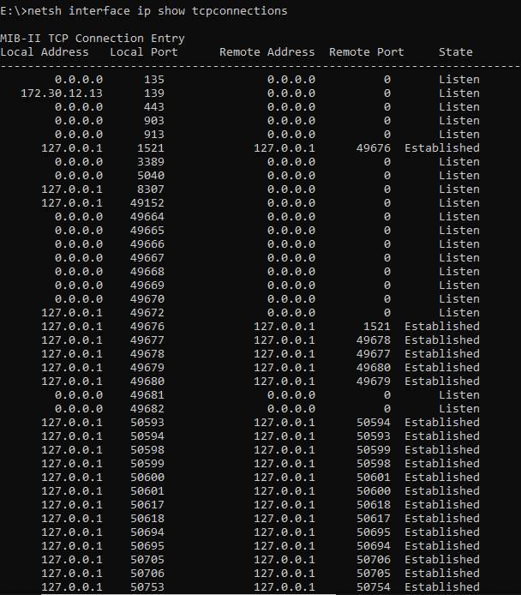

1. Information about all UDP Connections

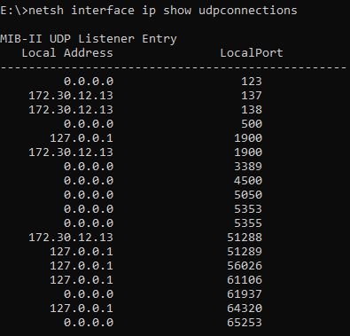

NOTE: Also upload these TEXT FILES in your submission.

**Text files also uploaded.**